Lesson 4 Homework | LT 1.1, 1.2, and 1.3 | 4-14 even, 21, 23-27 odd, 33-38, 40, 41  (draw picture for #33-38)

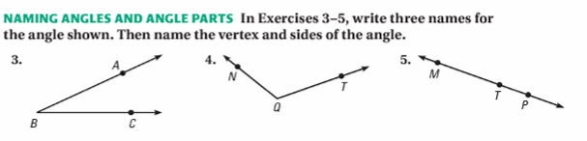

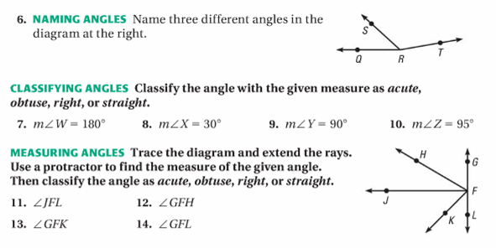

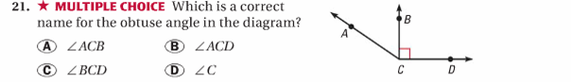

Lesson 4 Homework | LT 1.1, 1.2, and 1.3 | 4-14 even, 21, 23-27 odd, 33-38, 40, 41  (draw picture for #33-38)
